Town of Trinity Bay North
Public Auction of Land

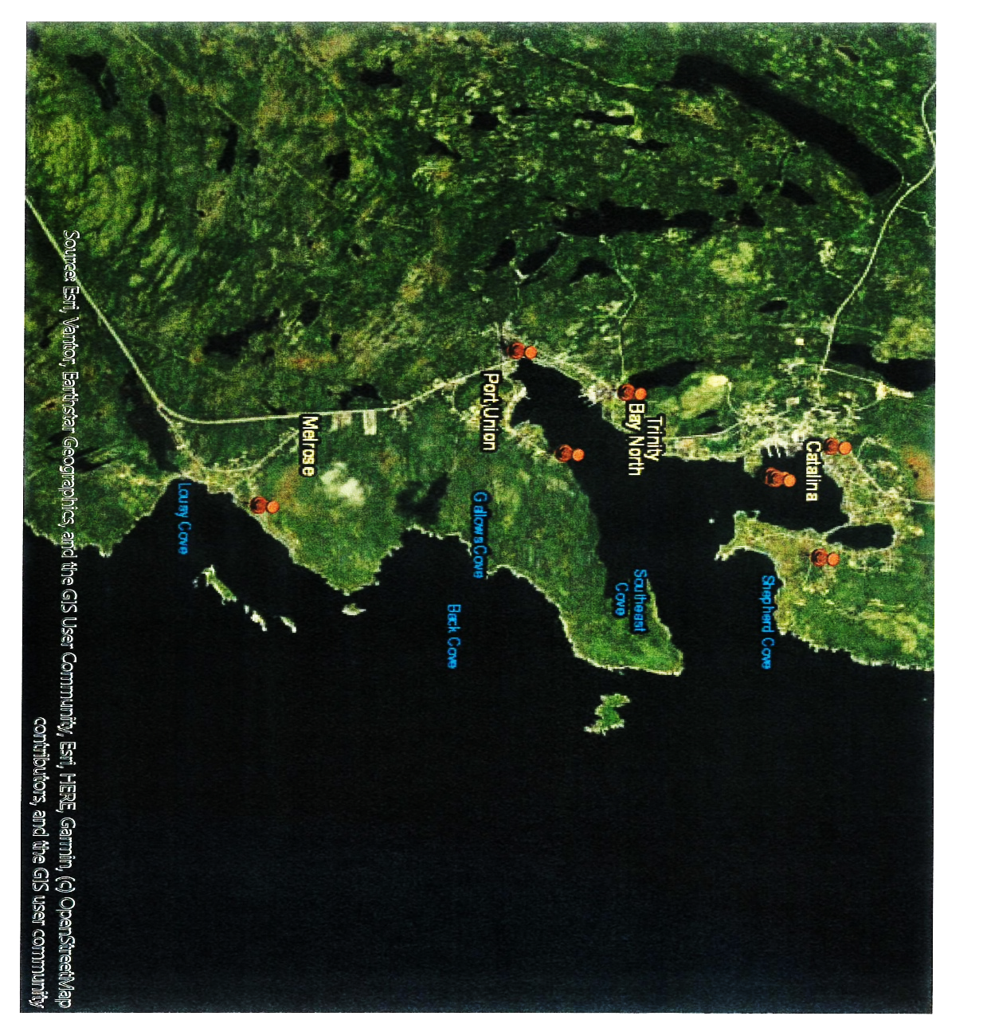

Friday, February 27th, 2026 @ 11:00 am
Frank Power Chalet, 48 Coaker Drive, Port Union, NL

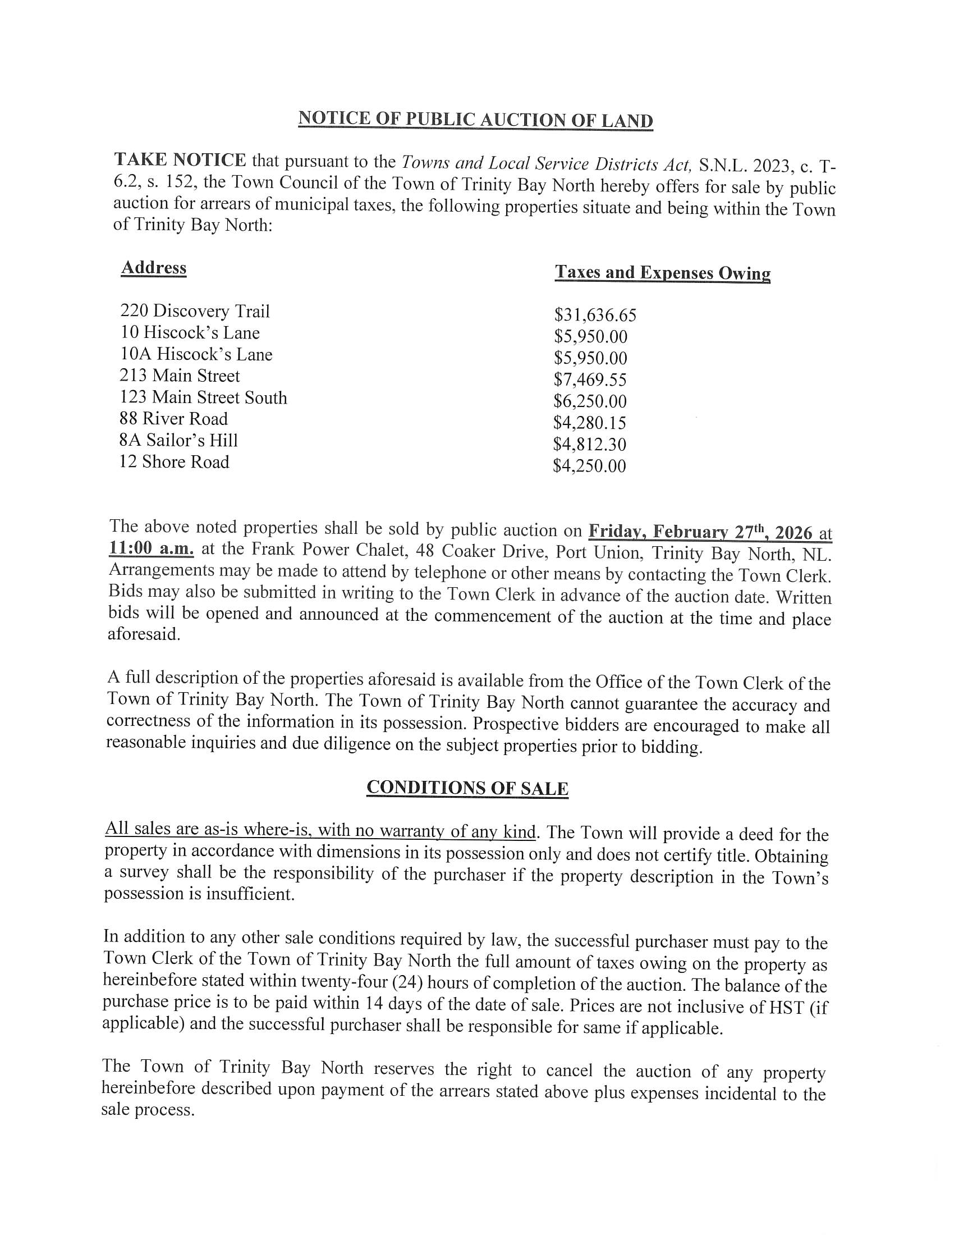

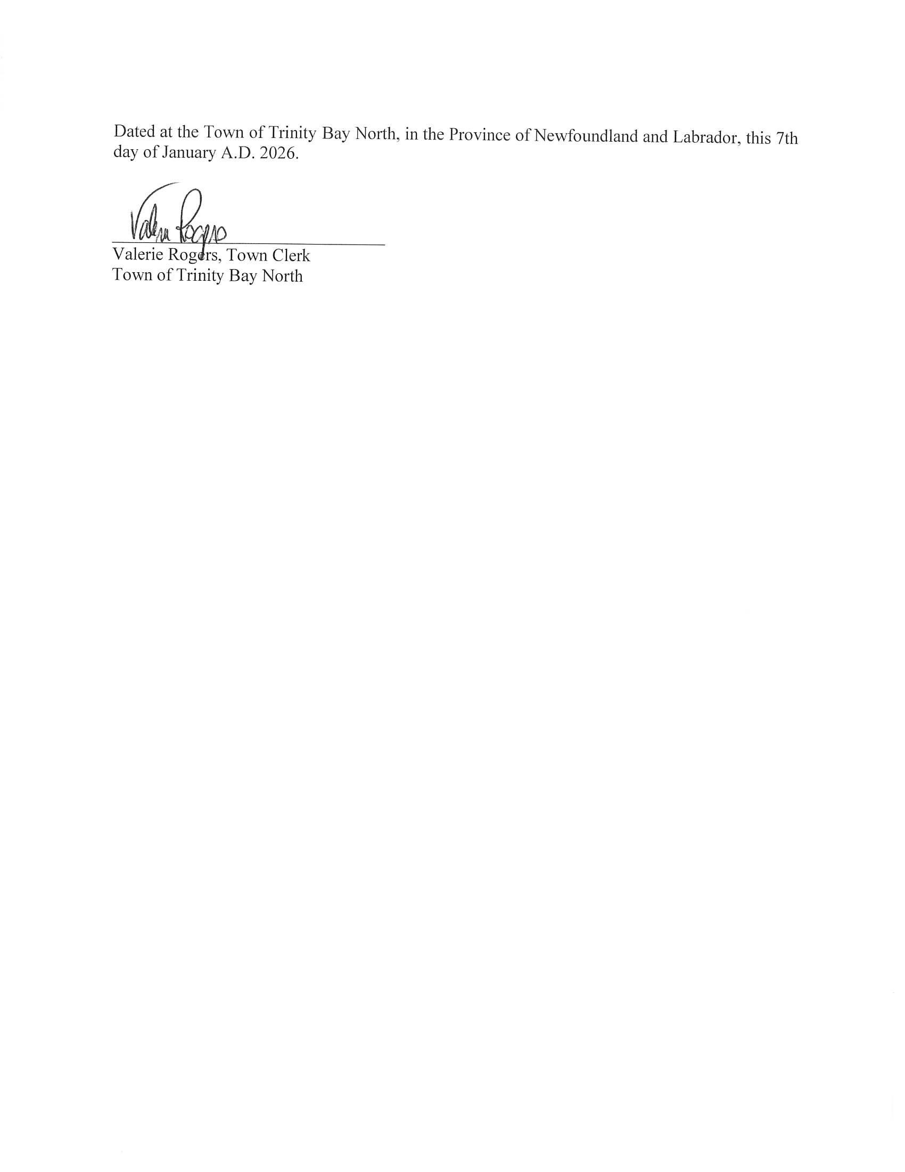

220 Discovery Trail
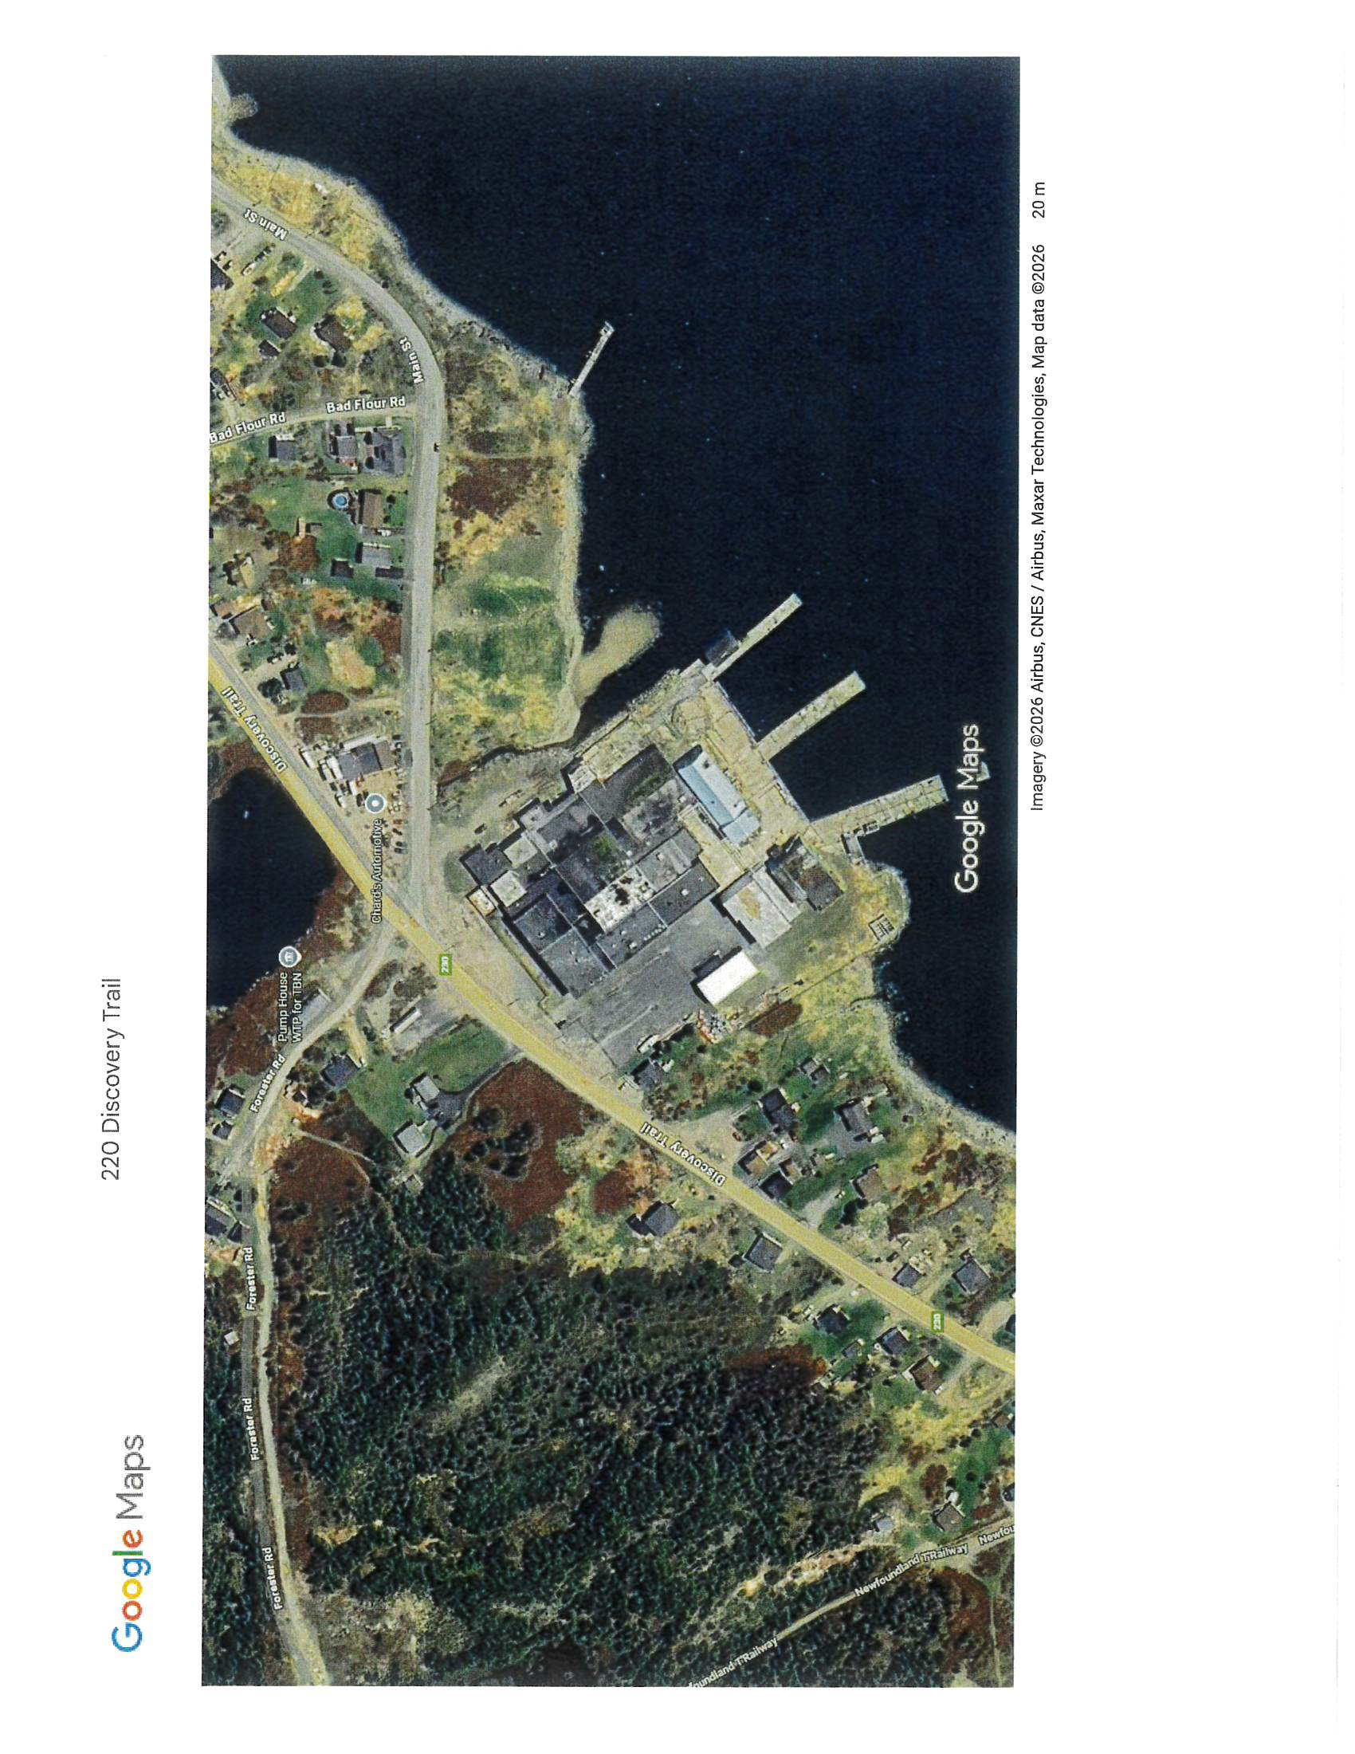
Owner: Trinity Bay North Development Corporation
Address: 220 Discovery Trail
Starting Bid: $31,636.65
Zoning: Mixed Development
Structures/Dwellings: Main Plant Building & Accessory Buildings. Does not include Carpenter Shop Building (See Survey)
Prospective bidders are encouraged to perform due diligence on properties prior to bidding. A review of Municipal Development Regulations and title searches is strongly encouraged.

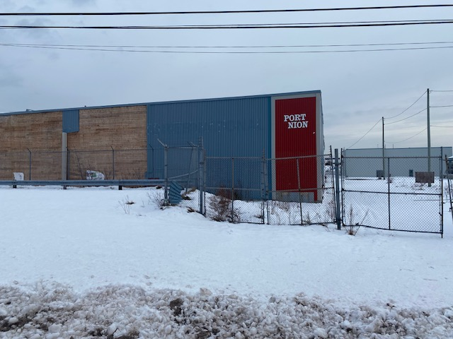

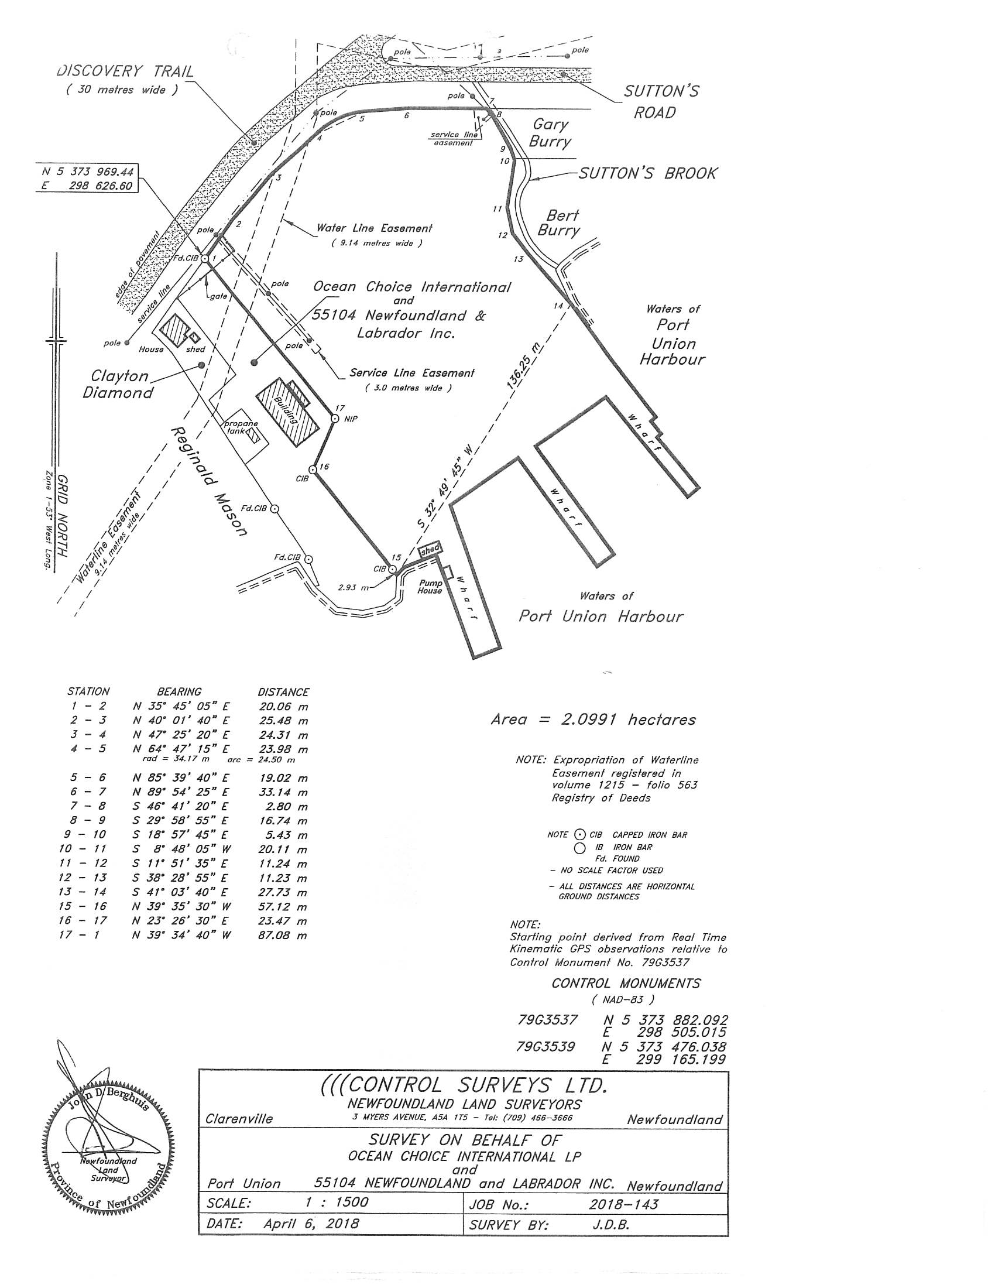

10 Hiscock’s Lane
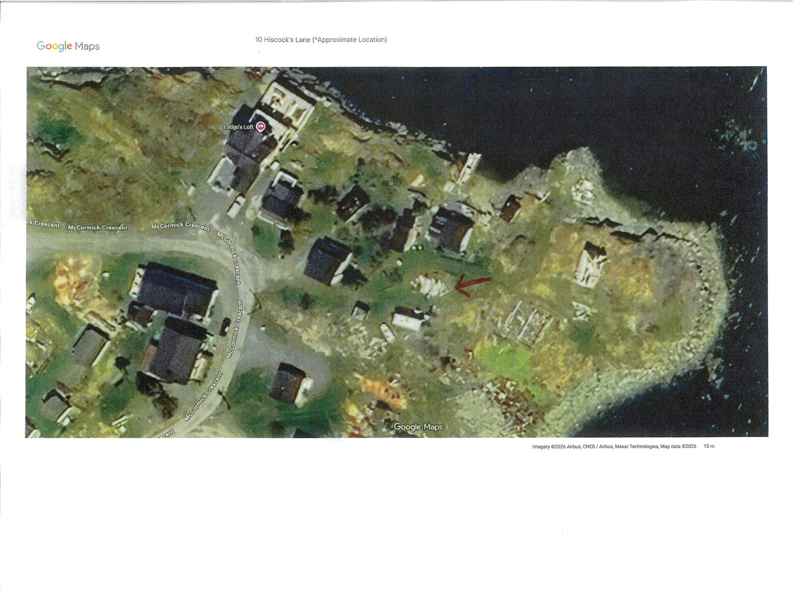
Owner: Estate of Calvin Hiscock
Address: 10 Hiscock’s Lane
Starting Bid: $5,950.00
Zoning: Mixed Development
Structures/Dwellings: Vacant
Prospective bidders are encouraged to perform due diligence on properties prior to bidding. A review of Municipal Development Regulations and title searches is strongly encouraged.

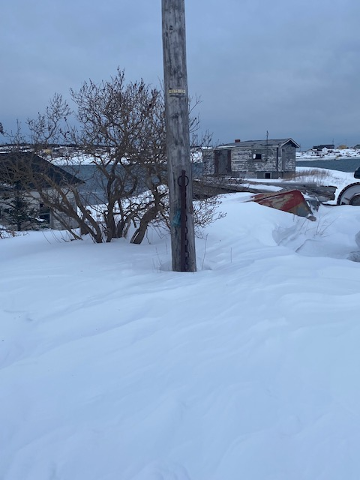

10 A Hiscock’s Lane
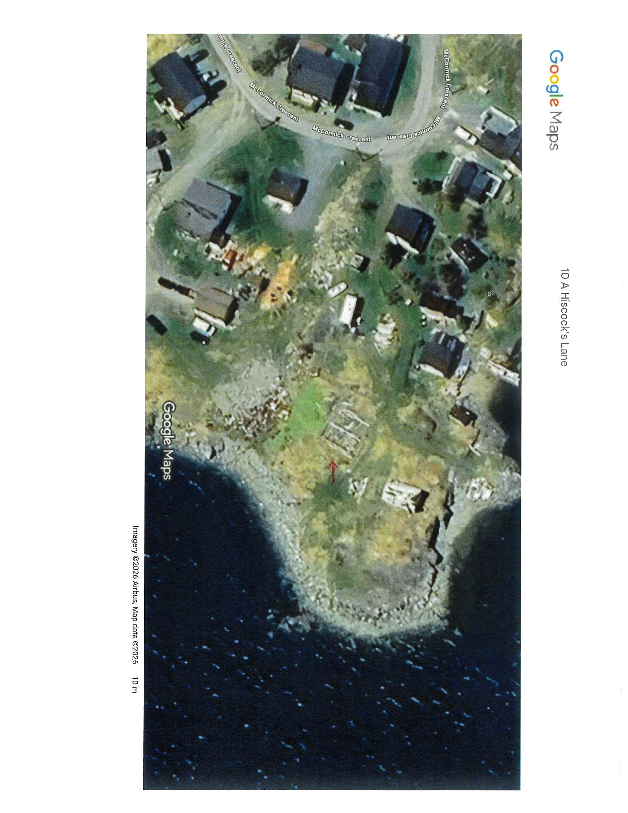
(*Approximate Location)

Owner: H & S White Enterprise Ltd.
Address: 10A Hiscock’s Lane
Starting Bid: $5,950.00
Zoning: Mixed Development
Structures/Dwellings: Vacant
Prospective bidders are encouraged to perform due diligence on properties prior to bidding. A review of Municipal Development Regulations and title searches is strongly encouraged.

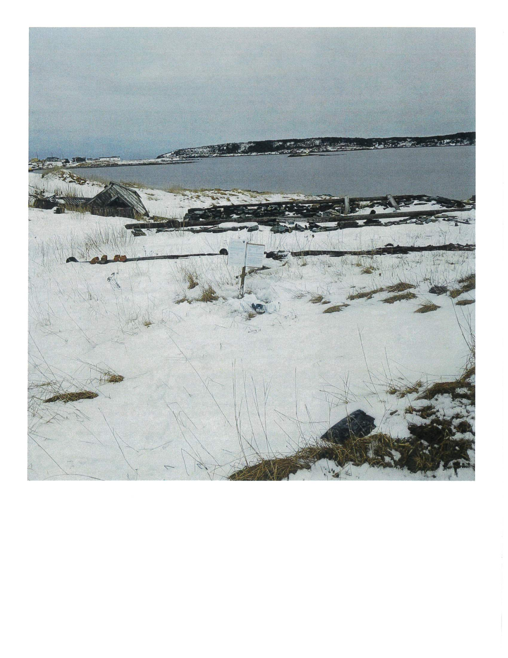

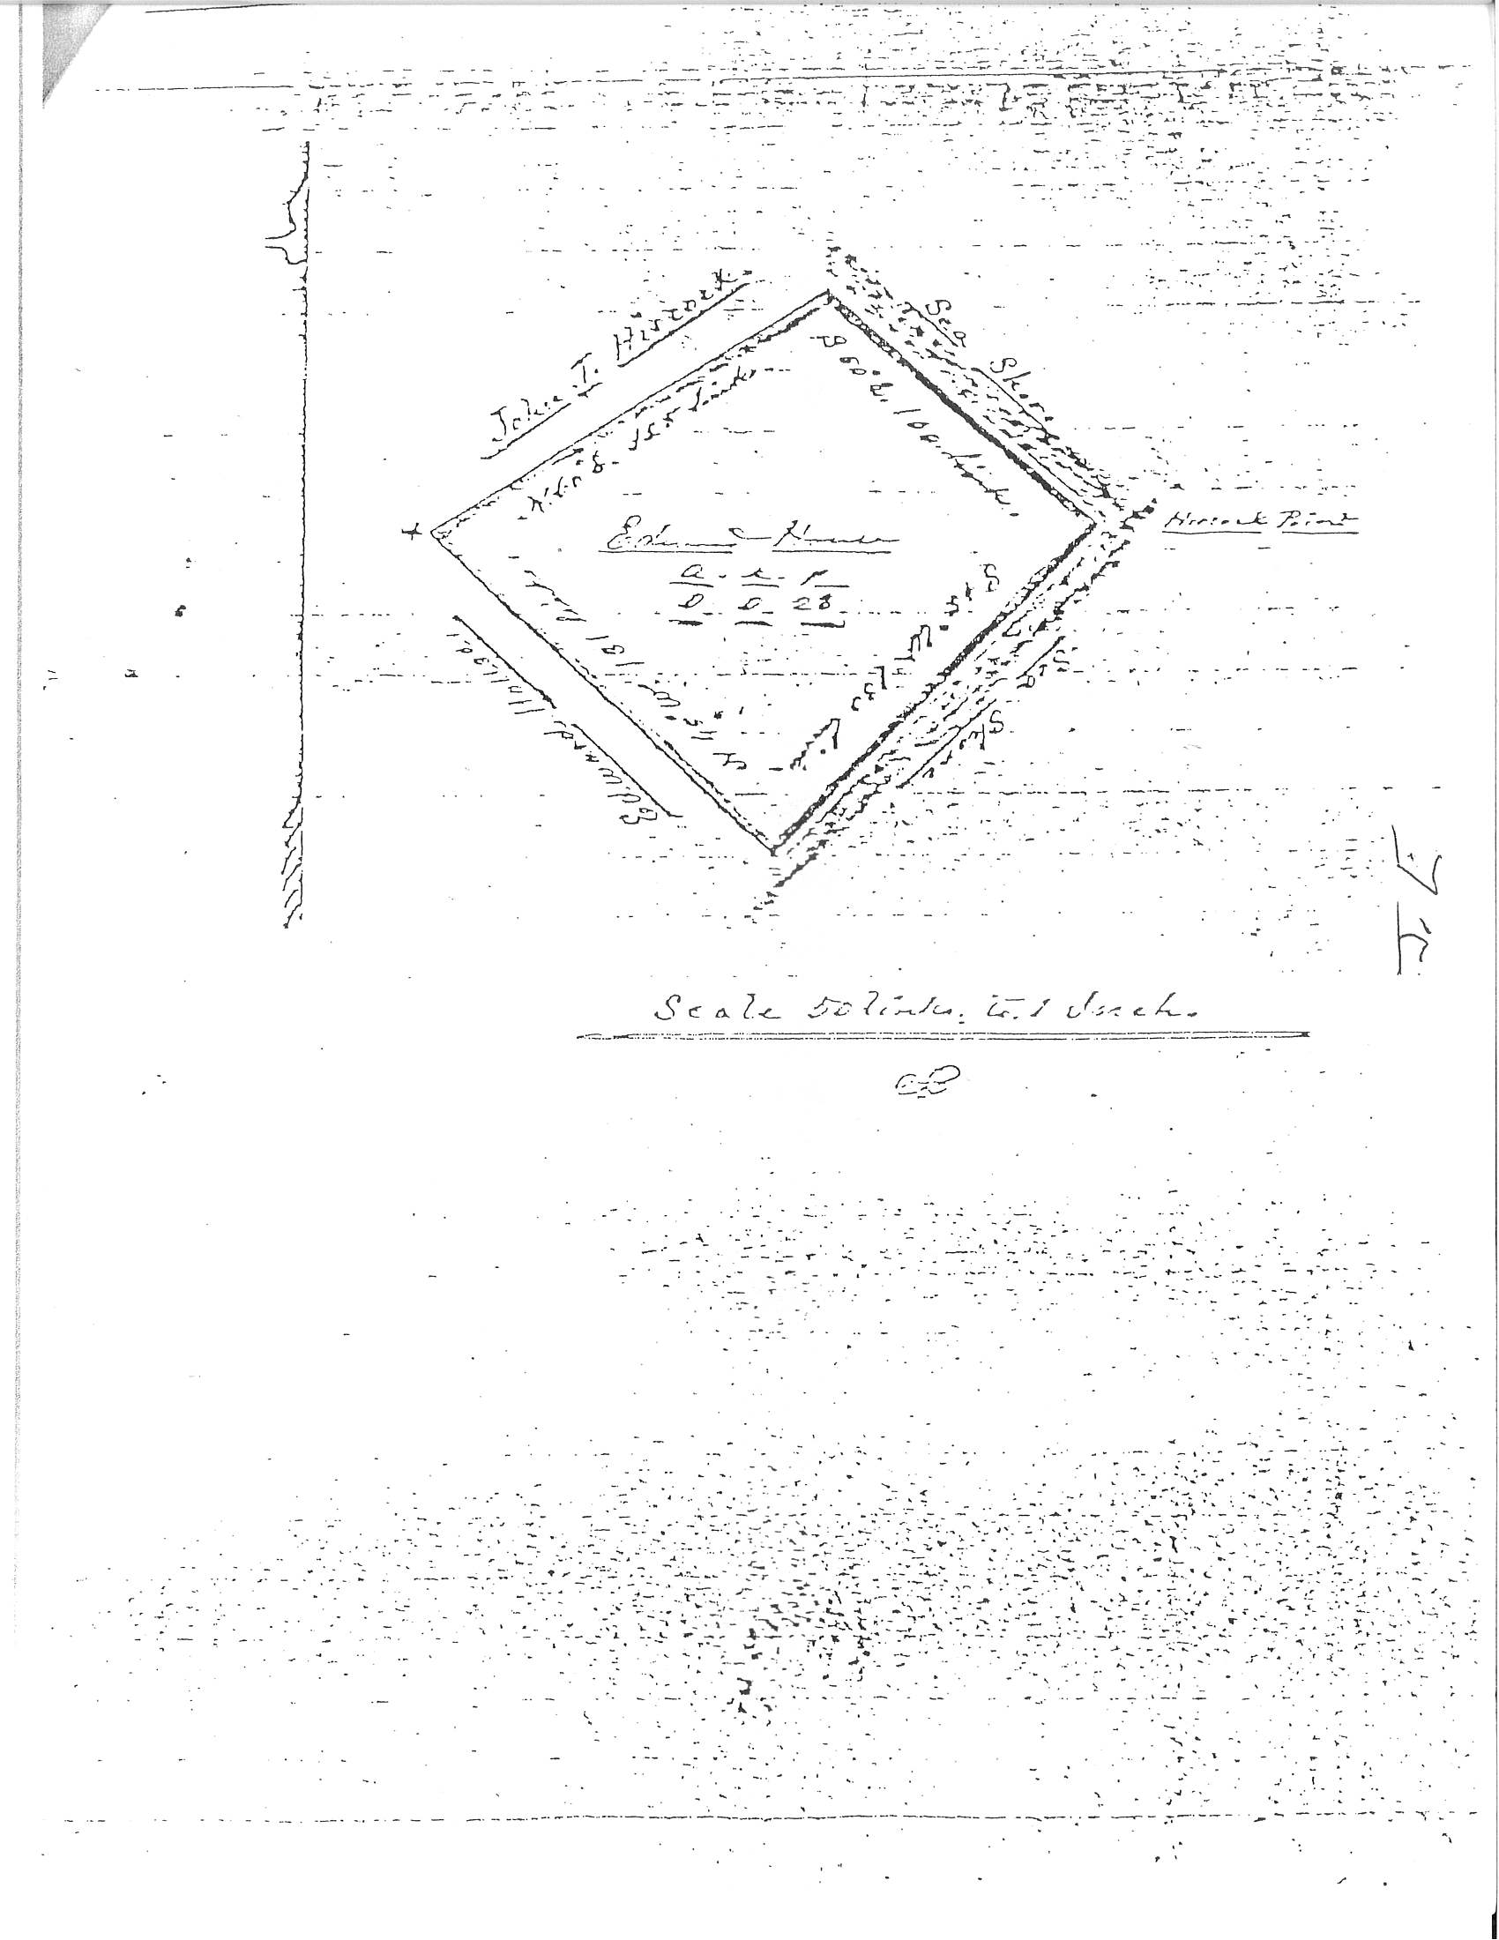

213 Main Street
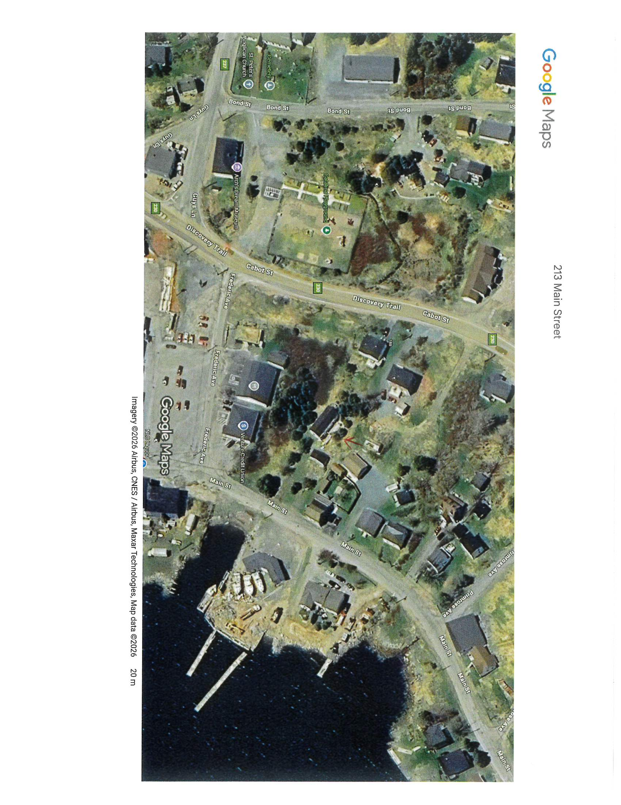
Owner: Stewart & Debbie Haynes
Address: 213 Main Street
Starting Bid: $7,469.55
Zoning: Mixed Development
Structures/Dwellings: Dwelling & Detached Building
Prospective bidders are encouraged to perform due diligence on properties prior to bidding. A review of Municipal Development Regulations and title searches is strongly encouraged.

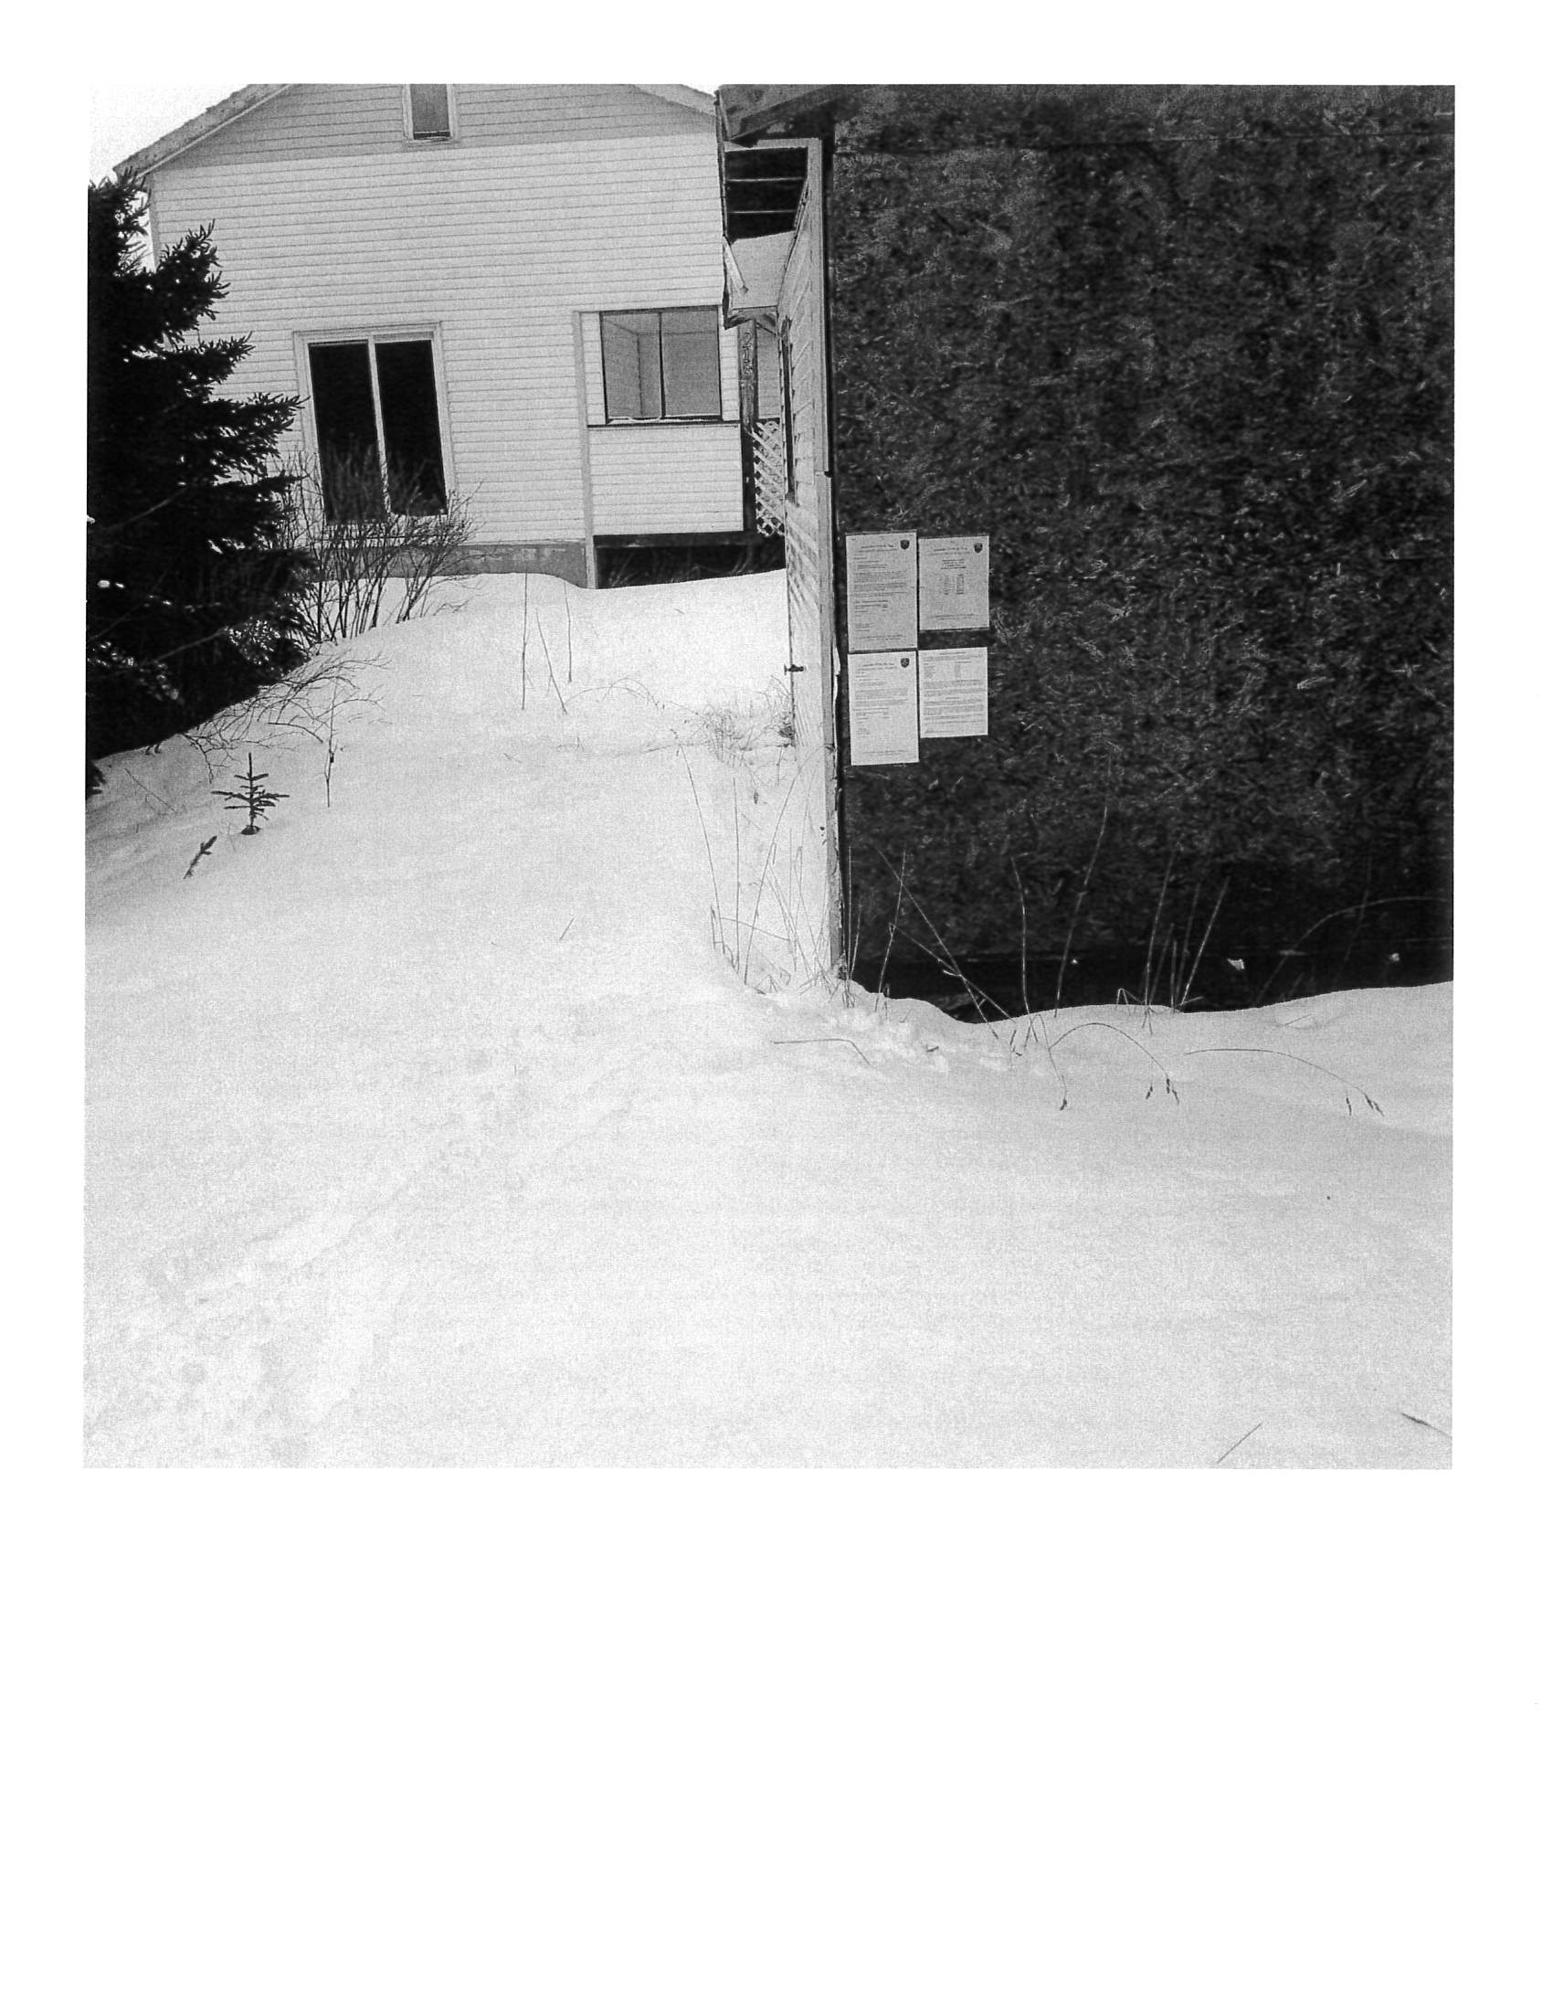

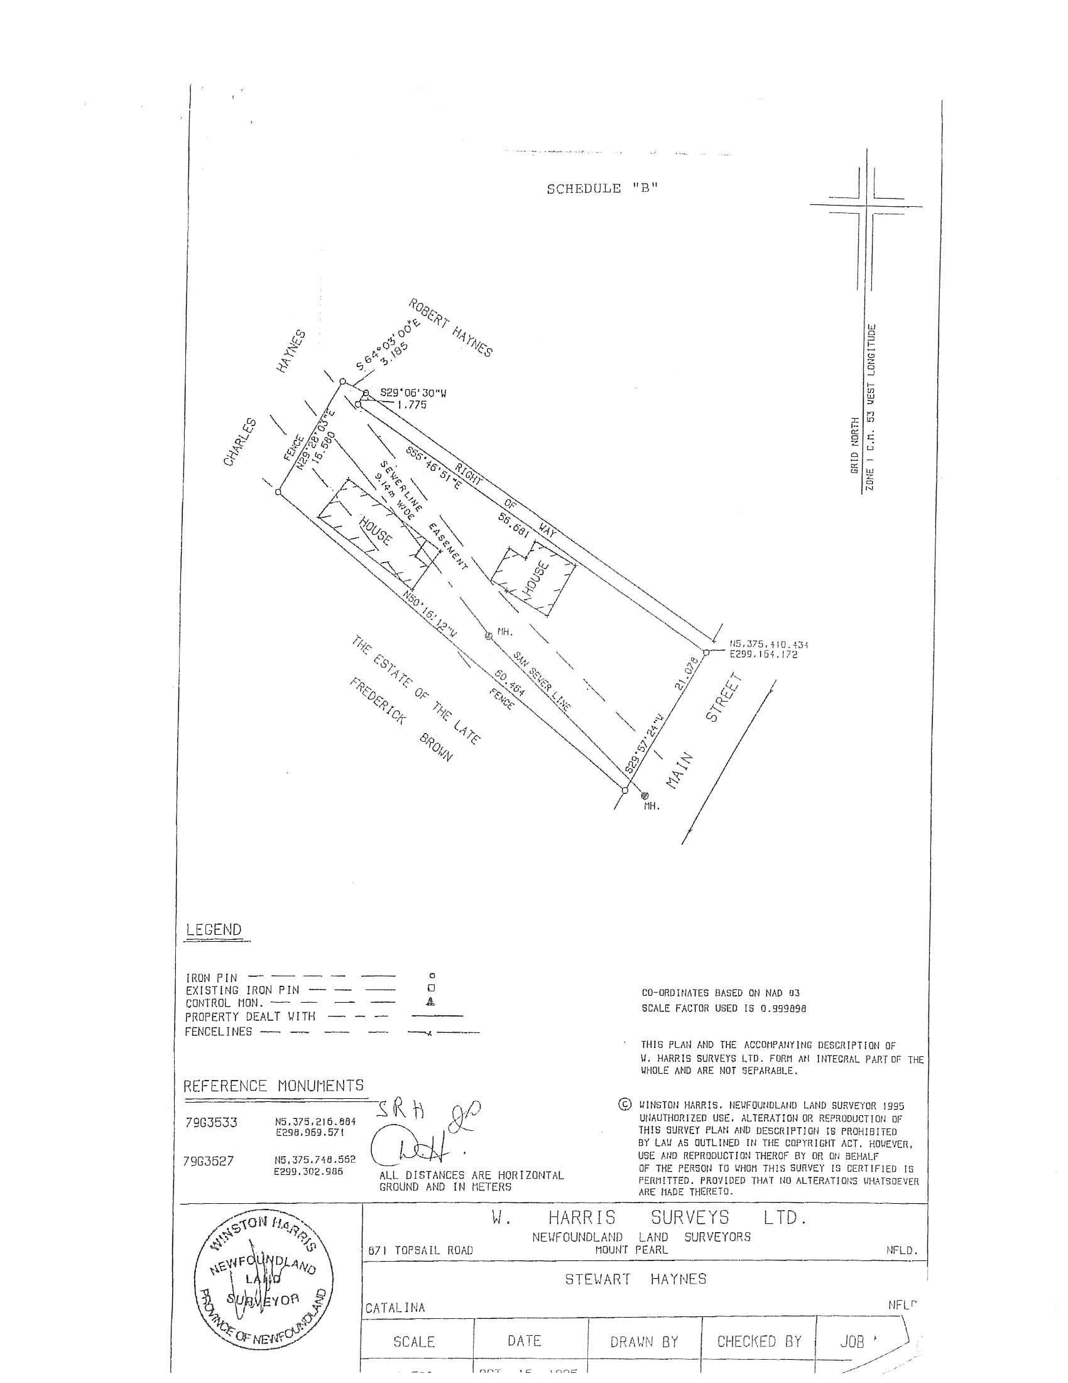

123 Main Street South
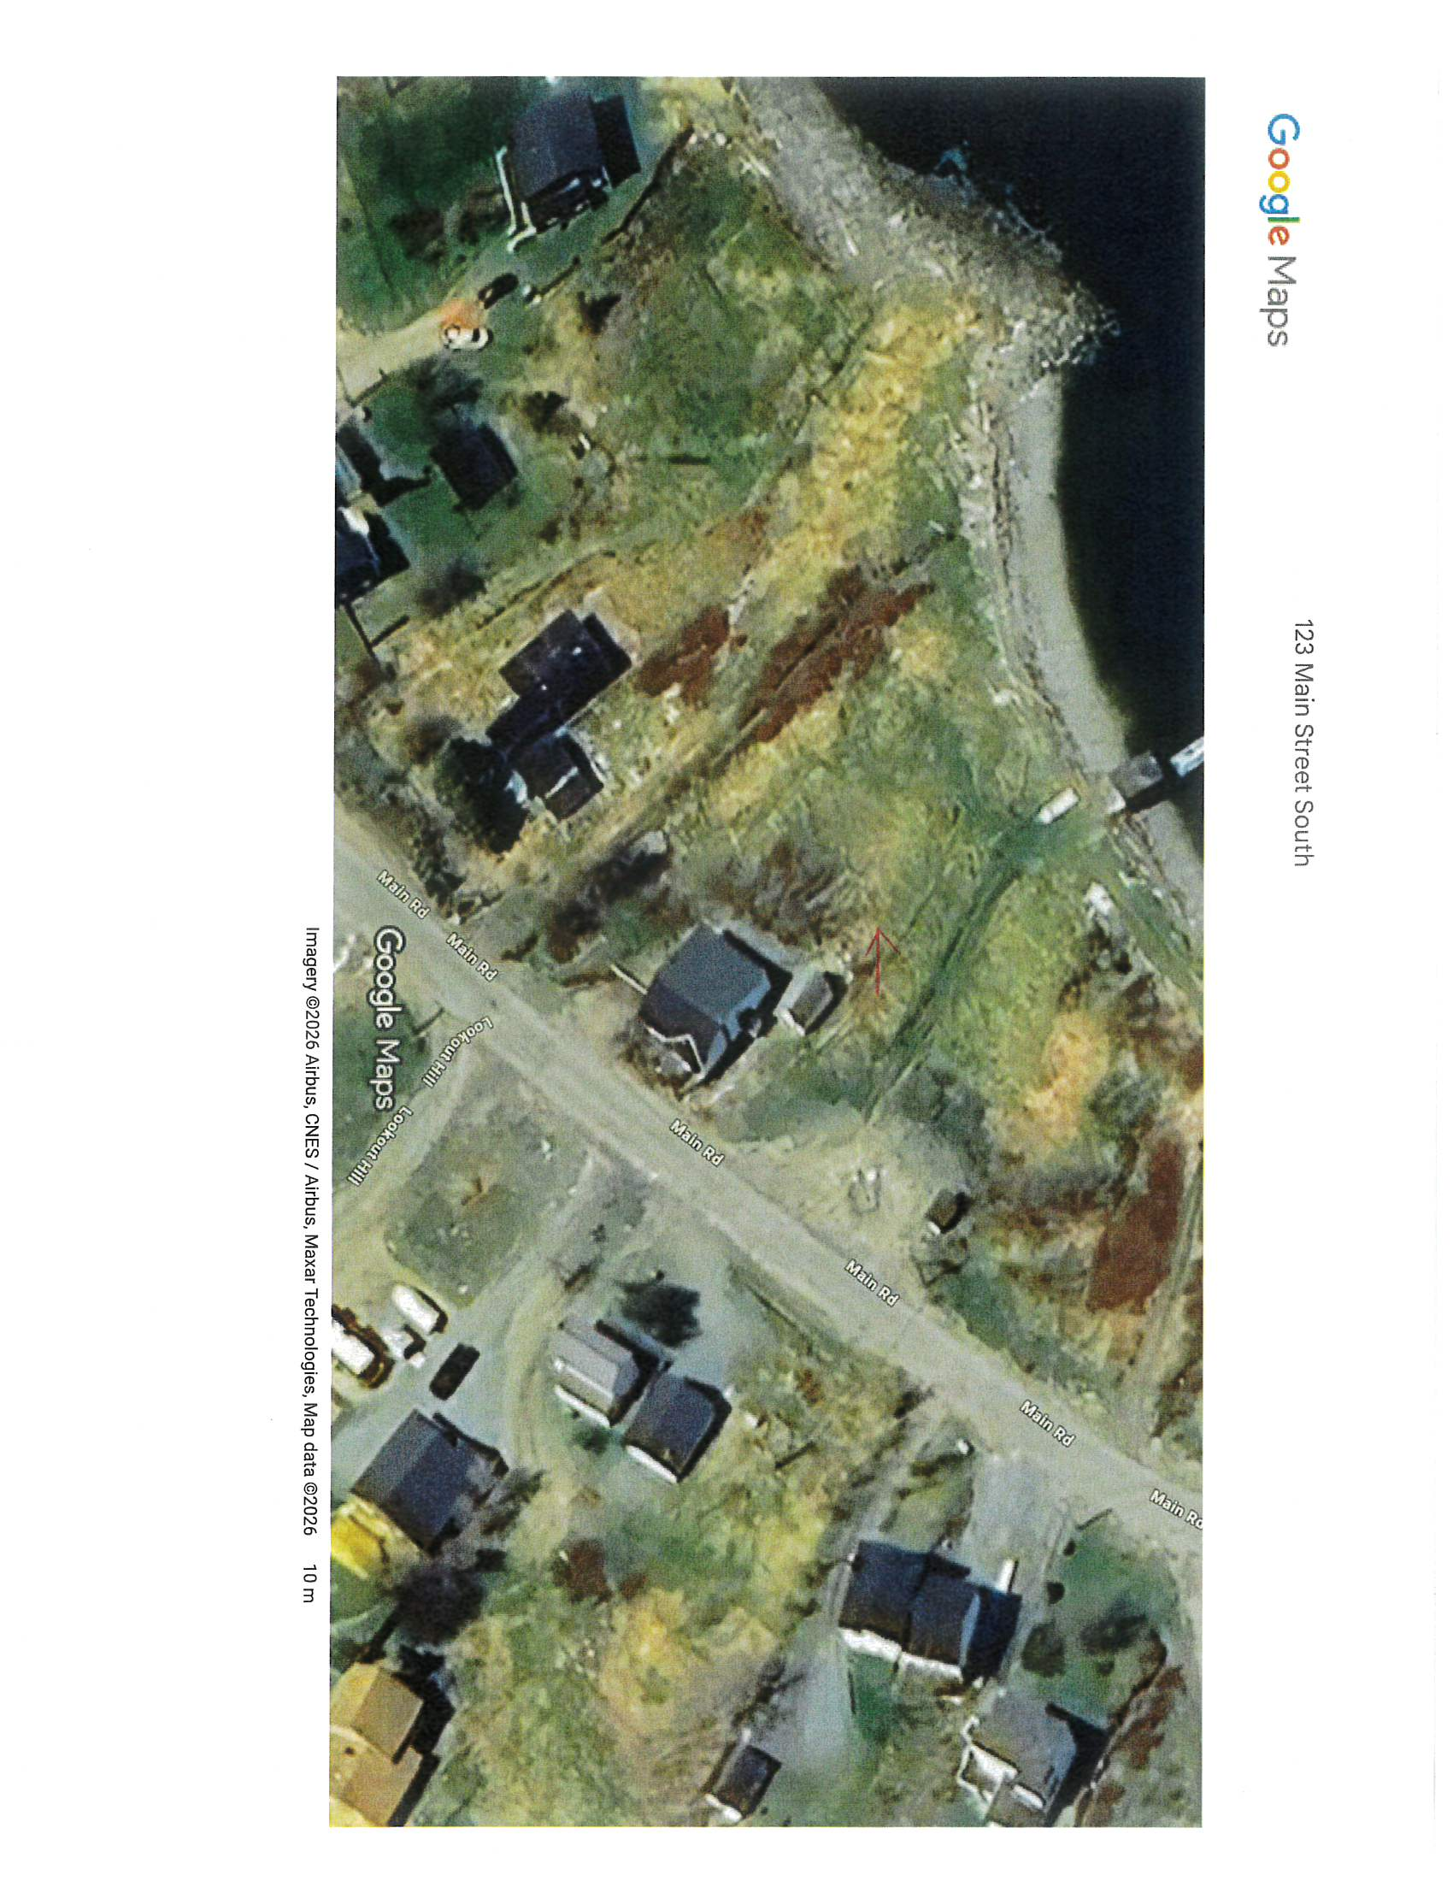
(*Approximate Location)
Owner: Roy Norman
Address: 123 Main Street South
Starting Bid: $6,250.00
Zoning: Residential
Structures/Dwellings: Vacant
Prospective bidders are encouraged to perform due diligence on properties prior to bidding. A review of Municipal Development Regulations and title searches is strongly encouraged.

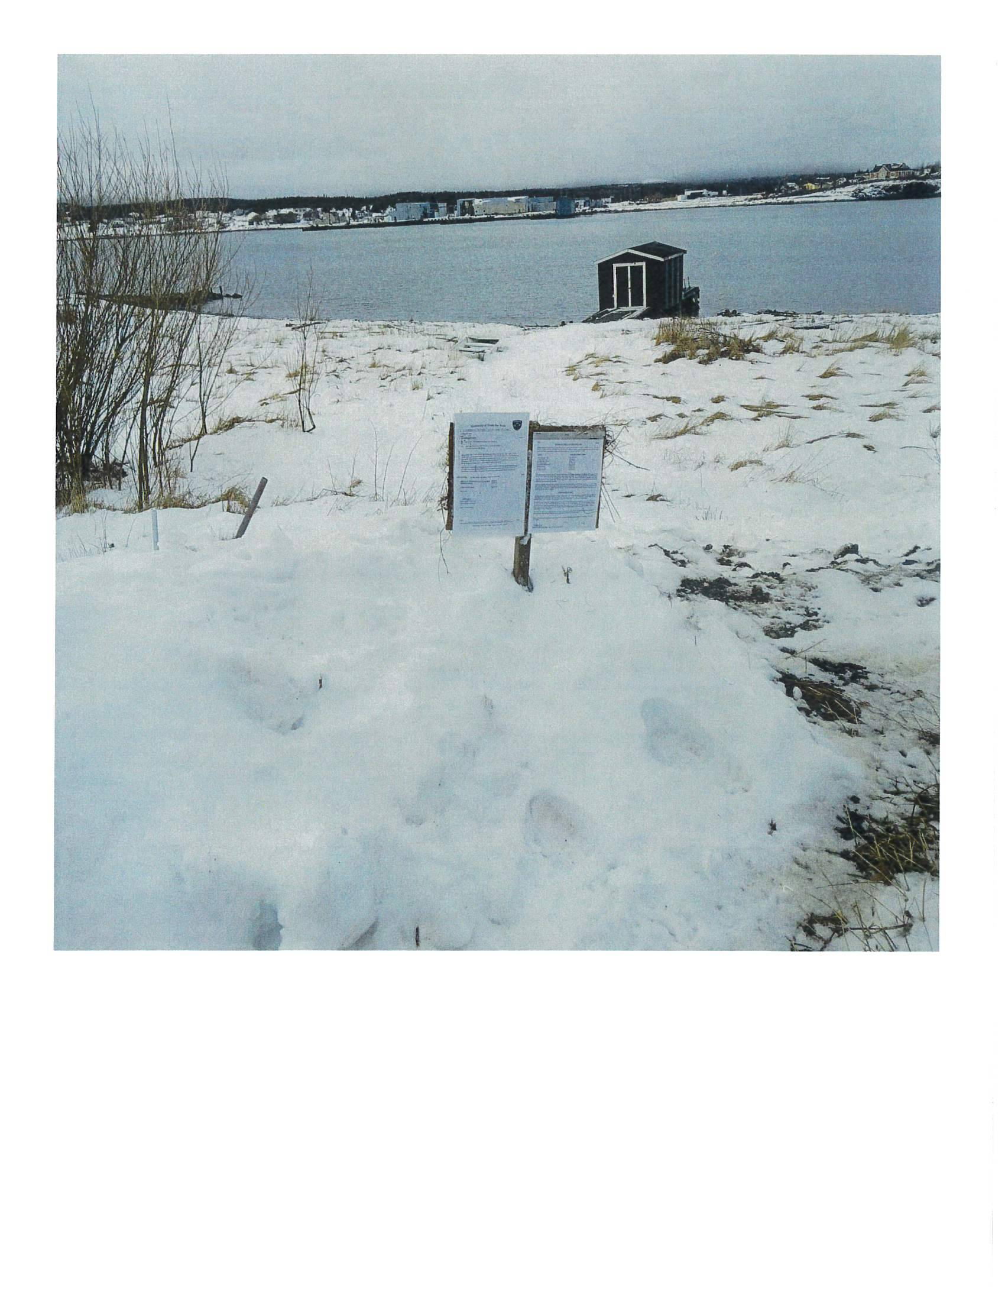

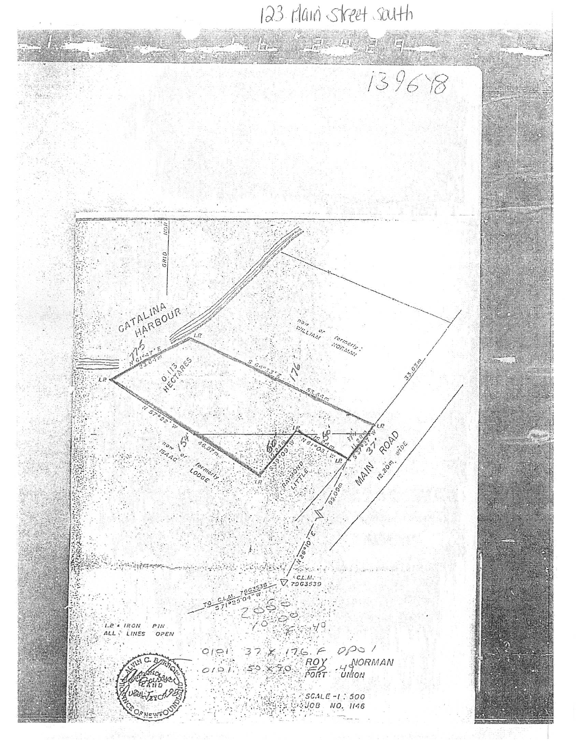

88 River Road
Owner: Roxanne Dyke
Address: 88 River Road
Starting Bid: $4,280.15
Zoning: Residential
Structures/Dwellings: Vacant
Prospective bidders are encouraged to perform due diligence on properties prior to bidding. A review of Municipal Development Regulations and title searches is strongly encouraged.

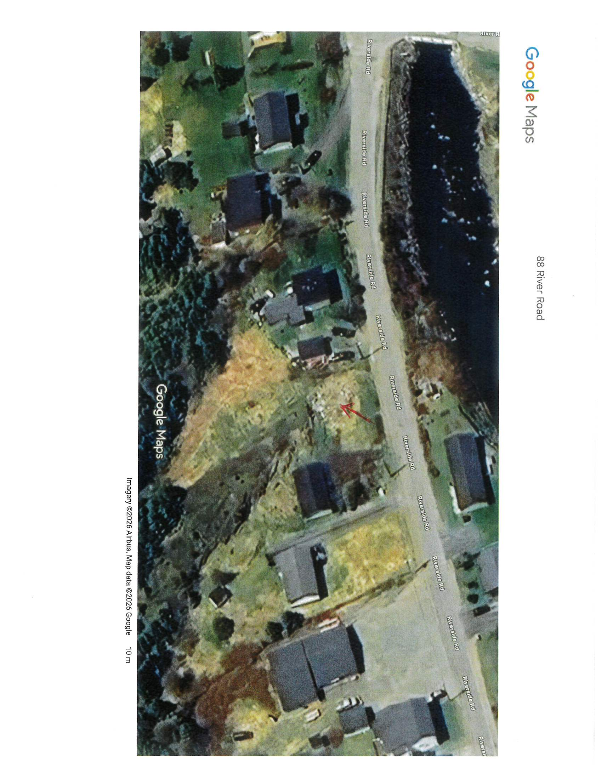
(*Approximate Location)

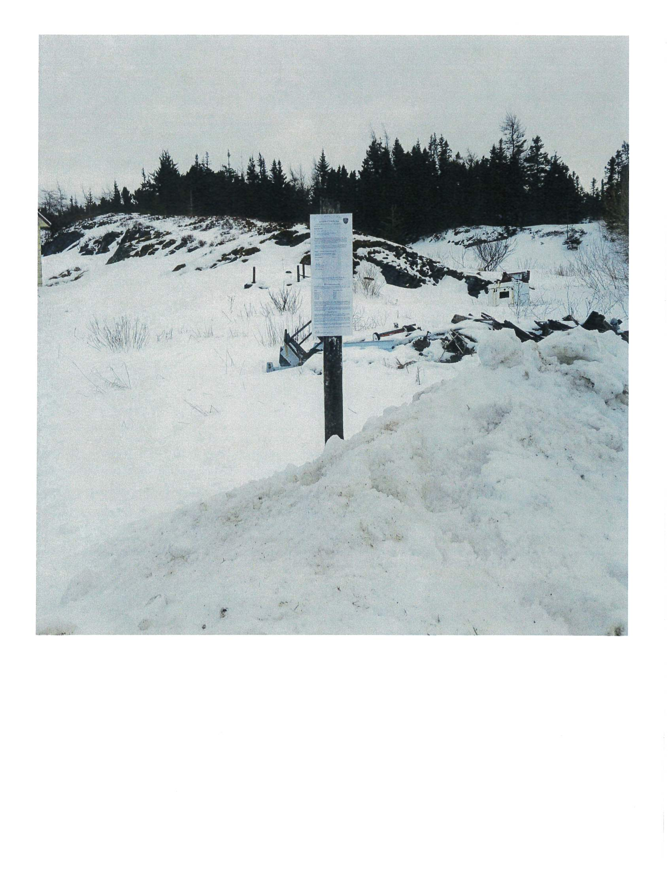

8A Sailor’s Hill
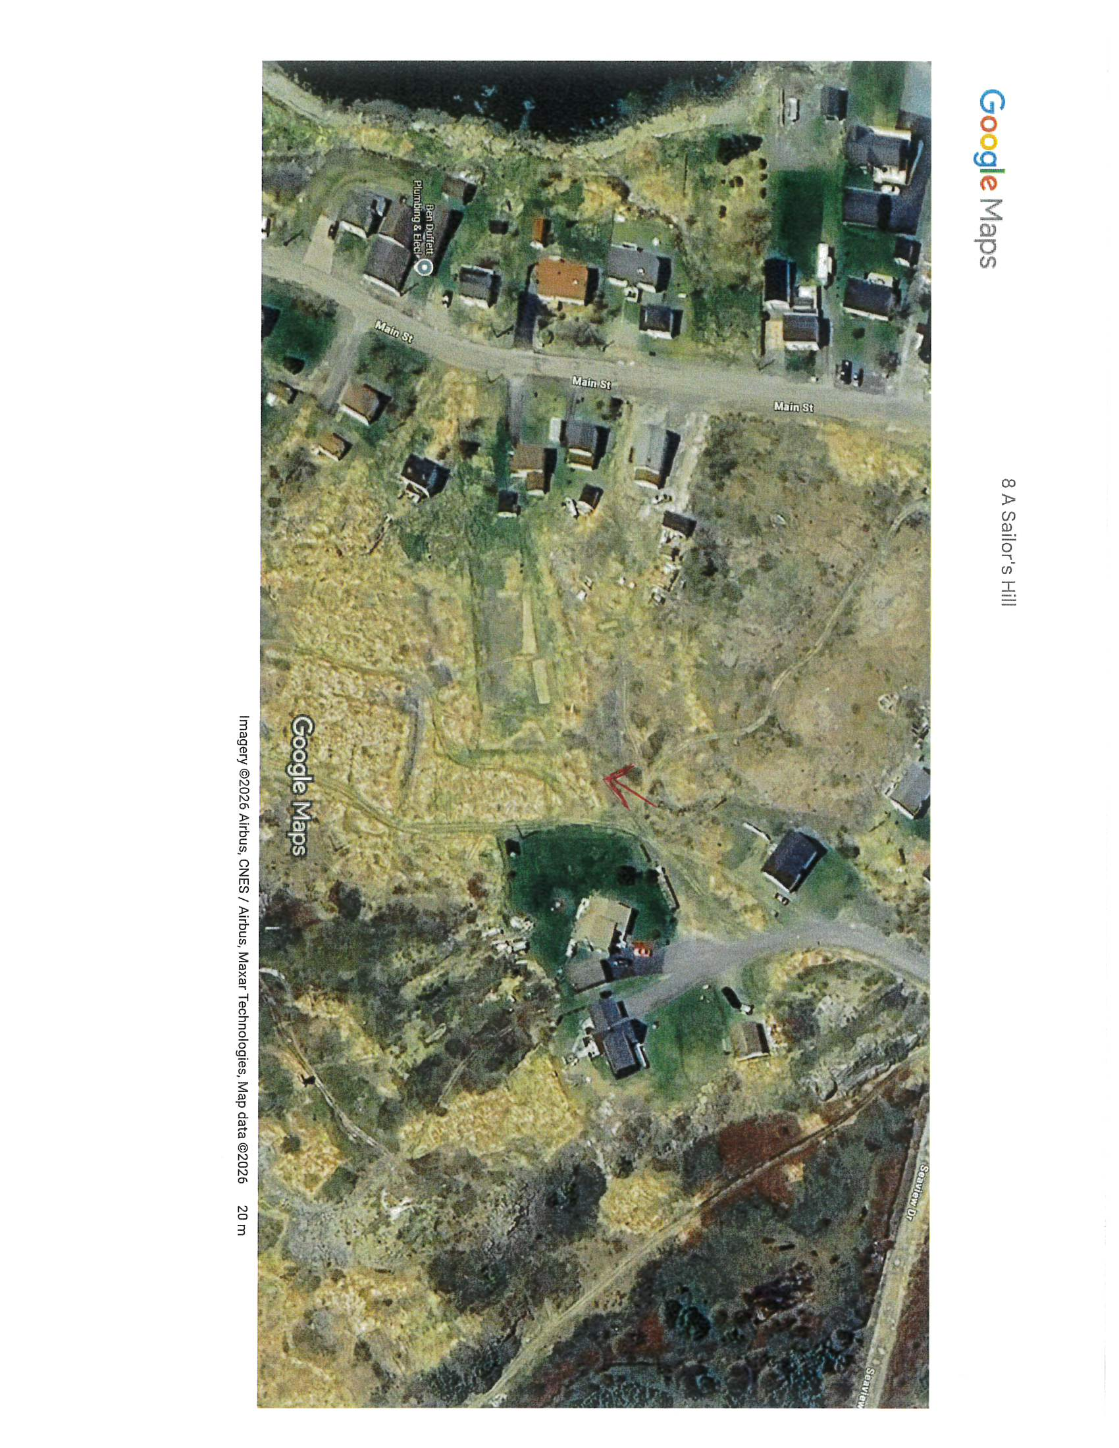
Owner: Estate of William Maidment
Address: 8A Sailor’s Hill
Starting Bid: $4,812.30
Zoning: Residential
Structures/Dwellings: Vacant
Prospective bidders are encouraged to perform due diligence on properties prior to bidding. A review of Municipal Development Regulations and title searches is strongly encouraged.

(*Approximate Location)

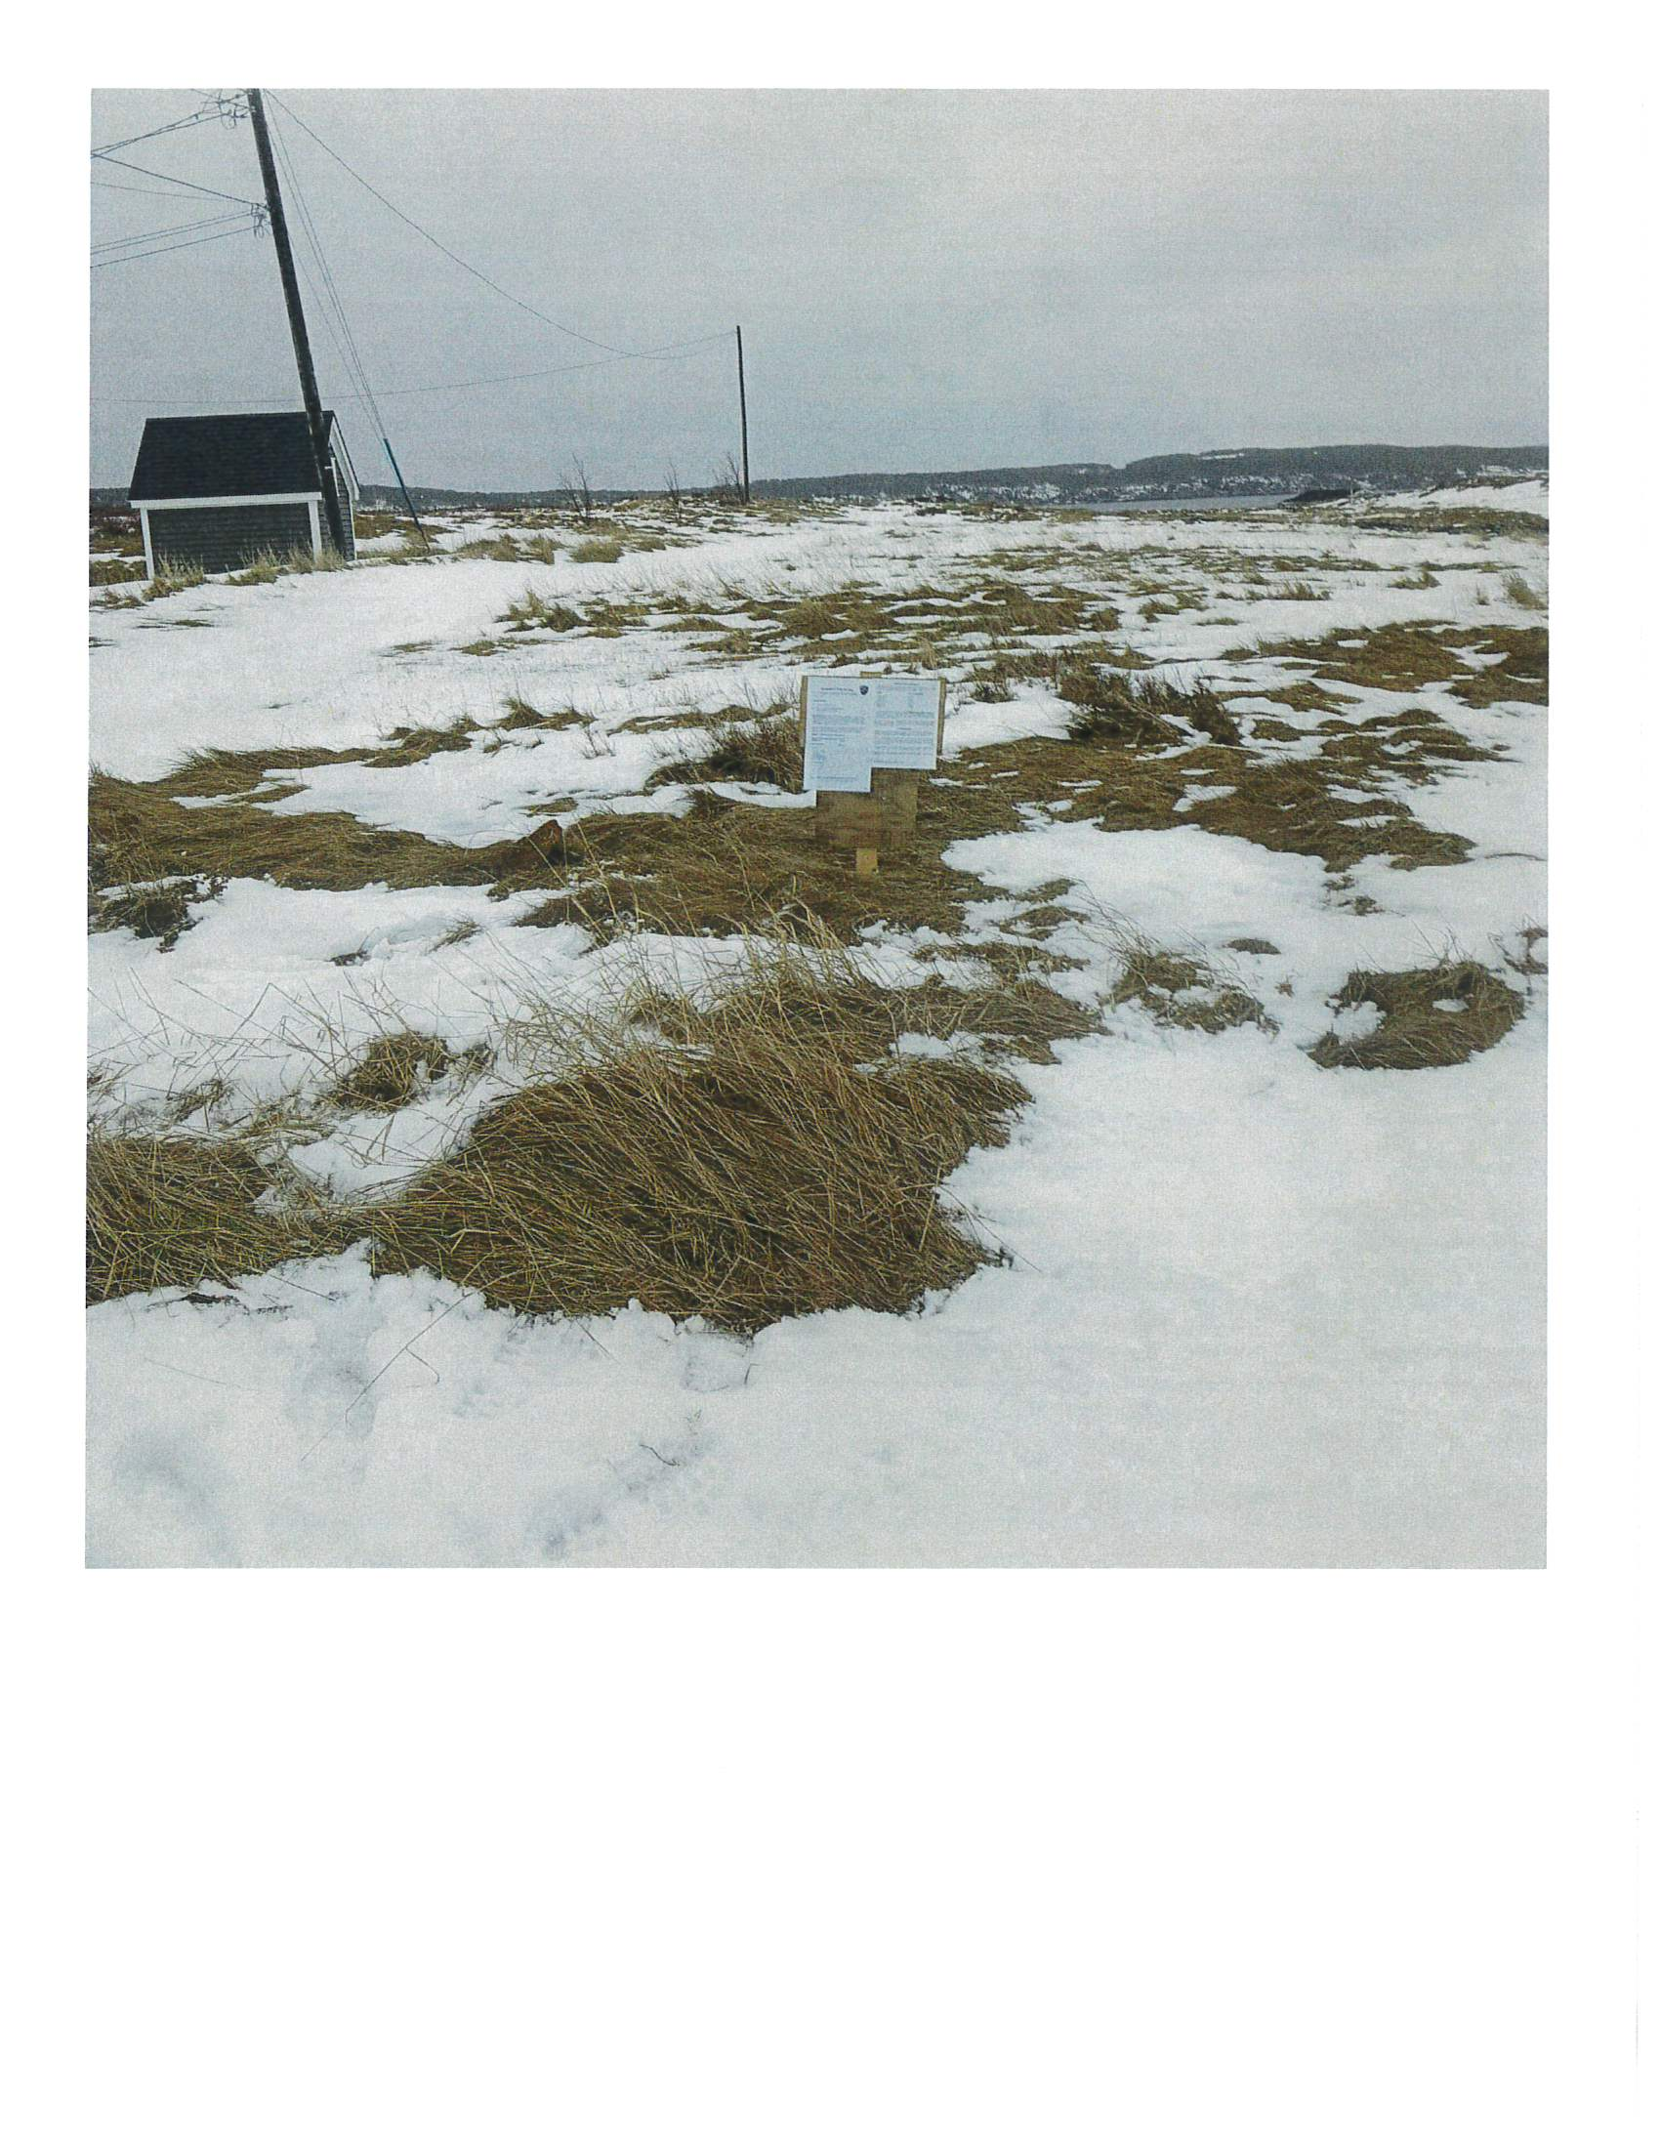

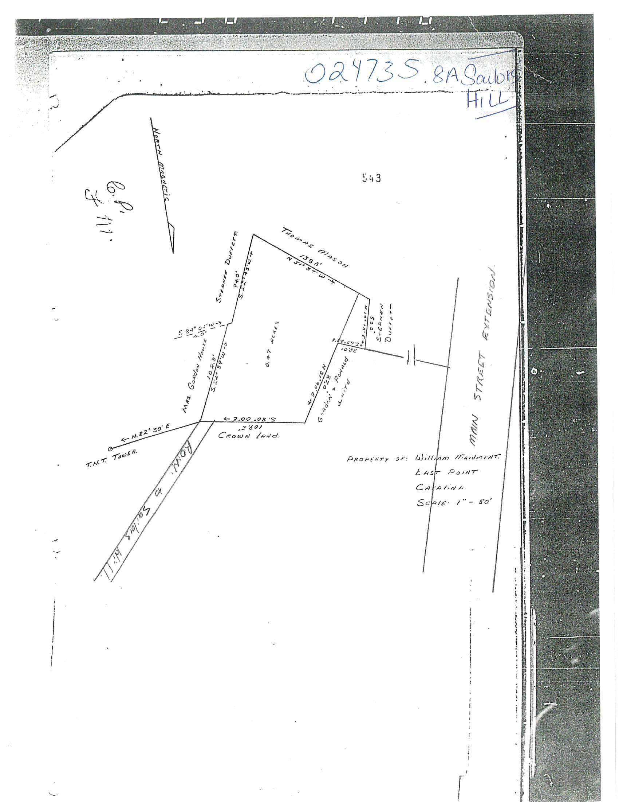

12 Shore Road
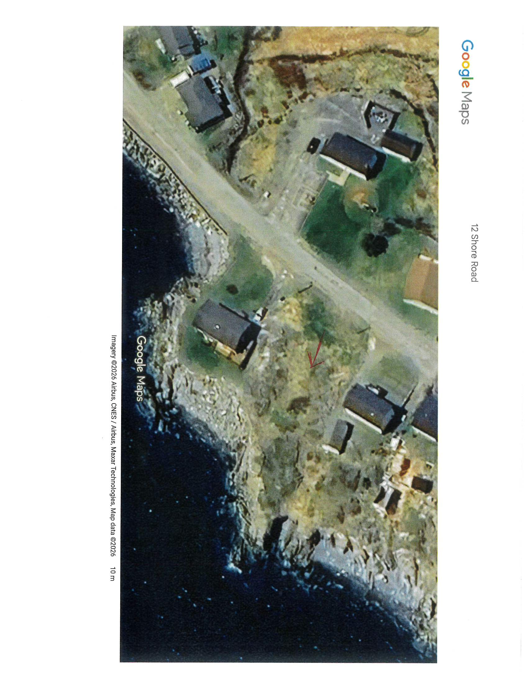
Owner: Renee Doody
Address: 12 Shore Road
Starting Bid: $4,250.00
Zoning: Residential
Structures/Dwellings: Vacant
Prospective bidders are encouraged to perform due diligence on properties prior to bidding. A review of Municipal Development Regulations and title searches is strongly encouraged.

(*Approximate Location)

